Measure Energy Consumption

**au410721104121**

# Phase-2 Document Submission

**Project:** Measure Energy Consumption

**Phase-2**: Innovation

**Mail.id: vasanthramp.cse2021@dce.edu.in**

# Time series analysis and machine learning models to predict future energy consumption patterns.

Predicting future energy consumption patterns is essential for efficient resource management and sustainability. A combination of time series analysis and machine learning models can provide valuable insights into these consumption patterns.

Time series analysis involves the examination of historical energy consumption data to identify underlying trends, seasonality, and patterns. By decomposing the time series into its constituent components, such as trend, seasonality, and residuals, we can gain a deeper understanding of how energy consumption fluctuates over time. These insights serve as a foundation for building predictive models.

Machine learning models, particularly regression and forecasting algorithms, can leverage historical data and additional features to make future consumption predictions. Feature engineering plays a critical role, as it involves selecting and engineering relevant variables that influence energy usage, such as weather data, time of day, economic indicators, and special events.

Selecting the appropriate machine learning model depends on the specific characteristics of the data and the prediction horizon. Techniques like Linear Regression, Random Forest, or Gradient Boosting can capture both linear and non-linear relationships. For more complex time series data, Recurrent Neural Networks (RNNs) and Long Short-Term Memory (LSTM) networks, which are a subset of deep learning, can be highly effective in capturing sequential patterns.

Cross-validation is employed to assess the robustness of these models, ensuring they generalize well to unseen data. Hyperparameter tuning fine-tunes the model's settings to optimize its predictive accuracy. Evaluating models using metrics like Mean Absolute Error (MAE) or Root Mean Squared Error (RMSE) quantifies their performance, and the best-performing model is selected for deployment.

Deploying the chosen model allows organizations to make informed decisions regarding energy resource allocation, pricing strategies, and demand forecasting. Real-time data integration can enable continuous monitoring and adaptive responses to changing consumption patterns. By documenting the entire process and adopting an iterative approach, organizations can consistently refine their predictive models, ensuring they remain relevant and effective in an ever-evolving energy landscape.

**System Architecture:**

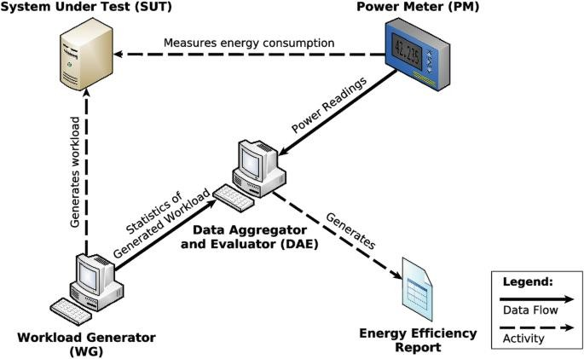

**Here is a high-level overview of how this could work:**

1. Presents a general approach to measure the energy consumed by a system as it executes a specific set of instructions.
2. Intel, one of the giant computer chip developers, developed an energy measuring and monitoring tool called Intel Power Gadget.
3. Intel Power Gadget provides callable APIs to get energy consumption information from code.
4. Intel is not the only computer hardware manufacturer to have made efforts in developing tools that measure and monitor energy consumed by hardware such as the CPU.

Benefits of using time series analysis and machine learning models to predict future energy consumption patterns

* Improved Resource Allocation
* Enhanced Grid Management
* Cost Reduction
* Environmental Sustainability
* Energy Conservation
* Demand Response
* Risk Mitigation
* Optimized Investment Planning
* Data-Driven Decision-Making
* Innovative Technologies
* Customer Engagement
* Energy Market Efficiency

Conclusion:

Predicting future energy consumption patterns through time series analysis and machine learning models is pivotal. It enables efficient resource allocation, grid stability, and cost reduction. Moreover, it contributes to environmental sustainability by promoting energy conservation and optimizing energy generation. These predictive models empower data- driven decision-making and innovation in the energy sector, ensuring a more sustainable and resilient future.